**Basic setup:** Ubuntu as in windows we have faced some issues with grun and compilation.

**Do the steps below:**

Step 0: Download [Teamviewer](https://www.teamviewer.com/en/) and install

Step 1: Download [oracle virtual box](https://www.virtualbox.org/) and install

Step 2: Download [ubuntu iso](https://www.ubuntu.com/download/desktop)

Step 3: Run virtualbox and make link with iso and run ubuntu(linux)

Step 4: [Getting Started](https://github.com/antlr/antlr4/blob/master/doc/getting-started.md) with **ANTLR v4**

Step 5: Successfully run example program for tree view and gui view

**View my pc through teamviewer:**

Username: 874 400 480

Password: 2127

**Ubuntu terminal shortcut:**

Open terminal: **ctrl+atl+t**

**Install java:**

1. **Done: sudo apt-get update**
2. **Done: java -version**
3. **Done: sudo apt-get install default-jre**
4. **Done: sudo apt-get install default-jdk**

**Antlr setup:**

1. **cd /usr/local/lib**
2. **curl -O http://www.antlr.org/download/antlr-4.7-complete.jar**
3. As permission denied, login as root user: **sudo su -**
4. **pwd , your current directory is /root**
5. **cd /usr/local/lib**
6. **export CLASSPATH=".:/usr/local/lib/antlr-4.7-complete.jar:$CLASSPATH"**
7. **alias antlr4='java -Xmx500M -cp "/usr/local/lib/antlr-4.7-complete.jar:$CLASSPATH" org.antlr.v4.Tool' alias**
8. **grun='java org.antlr.v4.gui.TestRig'**
9. **Cd /home/yourusername/cse375-project**
10. **Nano Hello.g4**

**// Define a grammar called Hello  
grammar Hello;  
r : 'hello' ID ; // match keyword hello followed by an identifier  
ID : [a-z]+ ; // match lower-case identifiers  
WS : [ \t\r\n]+ -> skip ; // skip spaces, tabs, newlines**

1. **cd /tmp**
2. **java -jar /usr/local/lib/antlr-4.7-complete.jar Hello.g4**
3. **javac Hello*.java**
4. **apt-get install grun**
5. **grun Hello r -tree**

**hello parrt // try with Hello parrt and get error, as no capital H**

**^D**

1. **grun Hello r -gui  
   hello parrt  
   ^D**
2. **Good practice not to face error**
   1. **Echo “string ” | grun grammarName productRule -tree or -gui**

**Proof:** 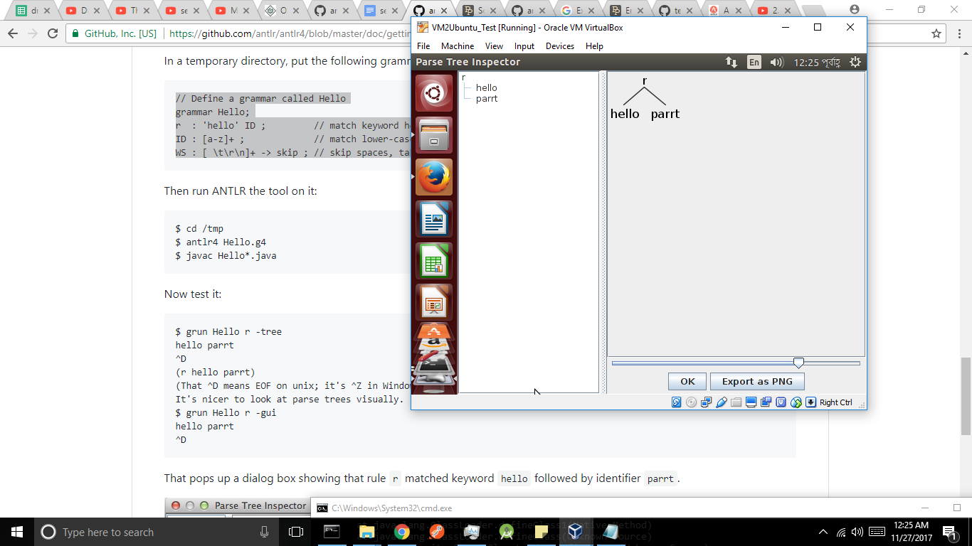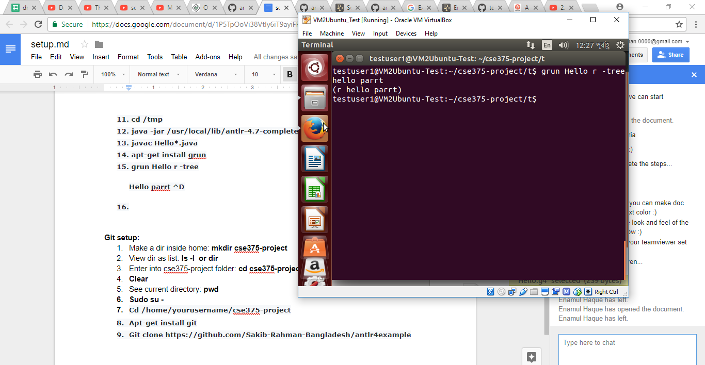

**Git setup:**

1. Make a dir inside home: **mkdir cse375-project**
2. View dir as list: **ls -l or dir**
3. Enter into cse375-project folder: **cd cse375-project**
4. **Clear**
5. See current directory: **pwd**
6. **Sudo su -**
7. **Cd /home/yourusername/cse375-project**
8. **Apt-get install git**
9. **Git clone** [**https://github.com/Sakib-Rahman-Bangladesh/antlr4example**](https://github.com/Sakib-Rahman-Bangladesh/antlr4example)

**Selected project: c**

**Download** [**grammar**](https://github.com/antlr/grammars-v4/tree/master/c)**,** [**examples**](https://github.com/antlr/grammars-v4/tree/master/c/examples)